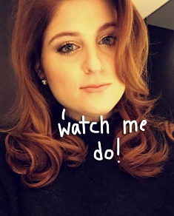***Watch me do* a World Tour**

Songs and Album

**Meghan Trainor World Tour 2019**

About Trainor

About Us

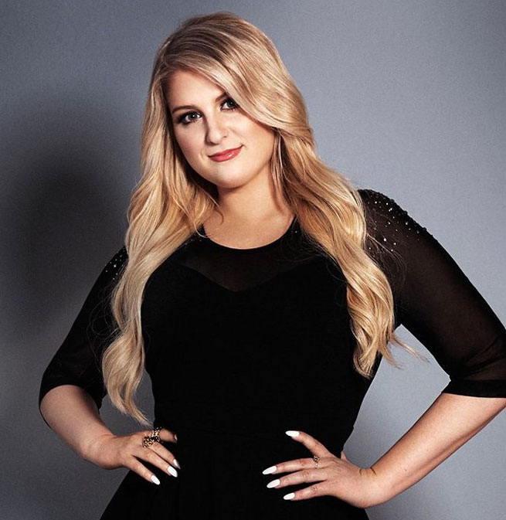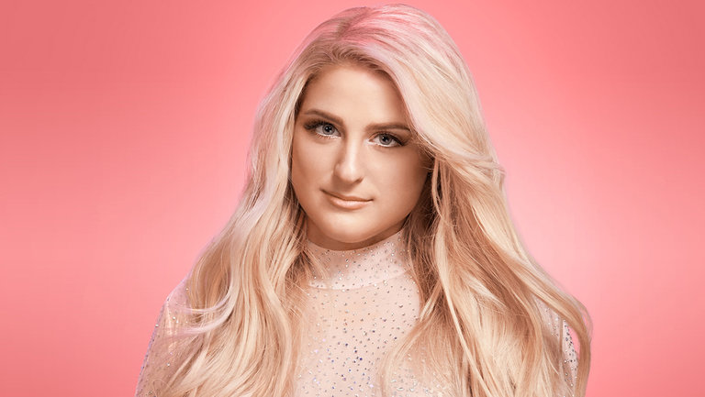

Follow Social media

Quotes

**About Us**

|  |  |  |  |  |  |
| --- | --- | --- | --- | --- | --- |
| **Date**    **Time** | **8th June** | **15th June** | **22th June** | **29th June** | **6th July** |
| **6p.m.** | Venue opens for everyone | Venue opens for everyone | Venue opens for everyone | Venue opens for everyone | Venue opens for everyone |
| **7p.m.** | Food and drink stalls will be opened outside the venue | Waiting for the arrival of audiences | Album signing/photo session with Trainor | Album signing/photo session with Trainor | Waiting for the arrival of audiences |
| **8p.m.** | Performance starts | Performance starts | Performance starts | Performance starts | Performance starts |
| **10p.m.** | Performance ends | Performance ends | Performance ends | Performance ends | Performance ends |
| **10:30p.m.** | Album signing/photo session with Trainor | Album signing/photo session with Trainor | Audiences leave the stadium | Audiences leave the venue | Audiences leave the venue |
| **12:00a.m.** | World Tour ends | World Tour ends | World Tour ends | World Tour ends | World Tour ends |

**\*Our schedule\***

**More information**

**8th June:** [**Seoul, Korea**](https://www.google.com/search?q=Seoul+Arts+Center+Concert+Hall&source=lnms&tbm=isch&sa=X&ved=0ahUKEwiSo_Dc2PLgAhWq63MBHYTBABQQ_AUIDigB&biw=1366&bih=651&dpr=1) **29th June:** [**Kuala Lumpur, Malaysia**](https://www.google.com.my/search?tbm=isch&sa=1&ei=MHaCXO6cKdjfz7sP89uY0A8&q=istana+budaya+MALAYSIA)

**15th June:** [**Tokyo, Japan**](https://www.google.com/search?q=Nippon+Budokan&stick=H4sIAAAAAAAAAONgVeLUz9U3MMwzMjc1UsrJLC5RyE9TKMnPrsxXyEosSMxTSM7PS04tKlEoS80rTS0-xYhQD2UbGyWXFEDZ5hnmJjkwtqV5VRGUnVSRlFNyipELxM4yM6oySIdyjMyK4nMqoBzT4srk9EoYJ804u8gMyjFOTrfIyHnEeIeRW-Dlj3vCUpcYJ605eY3xNCOXgE9-fnFqTmVQak5iSWpKSL6QEReba15JZkmlkBQXjxQH2C0padkaDFJcXHCeFI8SF-_sE66ioh7OzsFCTYxc3MGpJSH5vvkpmWmVQsVChVycvqm5SalFxf5pQilcXM75OTmpySWZ-XlCYVxaUmr6yXABfWgYxRekFqXlF-UmAnnxkPACWqrBRaRankWsUrhDHgDU-SxWqwEAAA&source=lnms&tbm=isch&sa=X&ved=0ahUKEwiT2arT2fLgAhXn73MBHbMLAC4Q_AUIDigB&cshid=1552053459666709&biw=1188&bih=566) **6th July: [Beijing, China](https://www.google.com/search?q=National+Centre+for+the+Performing+Arts&source=lnms&tbm=isch&sa=X&ved=0ahUKEwj8tMS92_LgAhVm8HMBHdm2C2QQ_AUIDigB&biw=1366&bih=651)**

**22th June:** [**Thailand**](https://www.google.com/search?q=IMPACT+Arena,+Exhibition+and+Convention+Center,+Muang+Thong+Thani&source=lnms&tbm=isch&sa=X&ved=0ahUKEwj_m6Sk2vLgAhWt6nMBHfIMBhwQ_AUIDygC&biw=1188&bih=566)

* born **December 22, 1993**

**Who is Trainor?**

* *American singer-songwriter*
* Interested in music from a **young age**
* wrote, recorded, and produced three **independently** released *albums*
  + between 2009 and 2011. Since signing with Epic Records in 2014, Trainor has released **two studio albums**
  + [*Title (2015)*](https://en.wikipedia.org/wiki/Title_(Meghan_Trainor_album))*, and*[*Thank You (2016)*](https://en.wikipedia.org/wiki/Thank_You_(Meghan_Trainor_album))
* earned six top 15 entries on the US *Billboard* Hot 100
  + "All About That Bass"
  + "Lips Are Movin"
  + "Dear Future Husband"
  + "Like I'm Gonna Lose You"
  + "No"
  + "Me Too"
* She has embarked on **three tours**
  + That Bass Tour
  + MTrain Tour
  + The Untouchable Tour.
* influenced by music from the 1950s and 1960s
  + known for her *throwback style.*
* lyrics refer to
  + modern womanhood
  + body image
  + empowerment
* pop artist and R&B artist
* received several **awards** and **nominations**
  + a Grammy Award
  + four ASCAP Pop Music Awards
* two *Billboard* Music Awards. Outside of music
* a **judge** on *The Four: Battle for Stardom.*
* A voice actress for animated films

Home

Back

Next

**1993–2008: Early life**

* Born in **Nantucket, Massachusetts**
* Mother and father: **Kelli and Gary Trainor**
* Her parents were both *jewellers*
* elder brother: Ryan
* younger brother: Justin
* singing at age **six**
  + at **church** with her father
* was a *music teacher*
* was an [*organist*](https://en.wikipedia.org/wiki/Organ_(music))
* interested in music **(early age)** 
  + influenced by her *family*.
* At 11, told her father that she wanted to become a recording artist and **began writing songs**
* recording them
  + using the digital audio workstation software [GarageBand](https://en.wikipedia.org/wiki/GarageBand)
* started with her own [arrangement](https://en.wikipedia.org/wiki/Musical_arrangement) of the [popular](https://en.wikipedia.org/wiki/Popular_music) song *"*[*Heart and Soul*](https://en.wikipedia.org/wiki/Heart_and_Soul_(1938_song))*"*
* Her mother said she picked up music **without formal training**
* Her father encouraged her to explore *every musical genre*
* Aged 12, began performing as part of the cover band, Island Fusion
  + with her aunt, younger brother, and father, performing [soca music](https://en.wikipedia.org/wiki/Soca_music) alongside her own compositions.
  + was in the group for four years, *singing, playing piano,*[*guitar*](https://en.wikipedia.org/wiki/Guitar)*and*[*bongo drums*](https://en.wikipedia.org/wiki/Bongo_drum)
* By age 13, written her first original song, **"Give Me a Chance".**
* left Nantucket when she was in the eighth grade, temporarily relocating to [Orleans, Massachusetts](https://en.wikipedia.org/wiki/Orleans,_Massachusetts) before moving to [**North Eastham**](https://en.wikipedia.org/wiki/North_Eastham,_Massachusetts)
* attended [*Nauset Regional High School*](https://en.wikipedia.org/wiki/Nauset_Regional_High_School)
  + studied guitar
  + played [trumpet](https://en.wikipedia.org/wiki/Trumpet)
  + sang in a [jazz band](https://en.wikipedia.org/wiki/Jazz_band) for three years
  + was a substitute [cheerleader](https://en.wikipedia.org/wiki/Cheerleading)
* While a teenager, Trainor's parents **encouraged her** 
  + to attend songwriting conventions
  + taking her to venues where production companies were searching for new artists and songwriters
* Aged 15, she took guitar lessons from *former*[*NRBQ*](https://en.wikipedia.org/wiki/NRBQ)*member* **Johnny Spampinato**
  + used [Logic Studio](https://en.wikipedia.org/wiki/Logic_Studio) to record and produce her compositions
  + also worked independently in a home studio built by her parents.

Next

Home

Back

Next

Home

Back

CAREER BEGINNINGS

Between the ages of 15 and 17, Trainor independently released three albums of material she had written, recorded, and performed. Her eponymous debut album, *Meghan Trainor*, was released on December 25, 2009, receiving airplay from local Massachusetts radio station [WCIB](https://en.wikipedia.org/wiki/WCIB). Trainor enrolled in the Summer Performance Program at the [Berklee College of Music](https://en.wikipedia.org/wiki/Berklee_College_of_Music) during the summers of 2009 and 2010, reaching the finals of the program's songwriting competition She released "Take Care of Our Soldiers" on April 16, 2010, a charity song in support of American troops abroad. The following year, Trainor released two [acoustic](https://en.wikipedia.org/wiki/Acoustic_music) albums, *I'll Sing with You* and *Only 17*.

At a music conference in [Colorado](https://en.wikipedia.org/wiki/Colorado), Trainor was introduced to former NRBQ member, [Al Anderson](https://en.wikipedia.org/wiki/Al_Anderson_(NRBQ)). He was impressed by Trainor's songwriting and referred her to his publisher, Carla Wallace at [Nashville](https://en.wikipedia.org/wiki/Nashville)-based Big Yellow Dog Music. Though Trainor had been offered a full scholarship to the Berklee College of Music, she decided to pursue her songwriting career and signed with Big Yellow Dog. She began her career as a songwriter-for-hire because of her ability to tackle a variety of genres She began by publishing songs for others and was unsure about becoming a recording artist. Her father said, "She thought she was one of the chubby girls who would never be an artist". Trainor graduated from Nauset Regional High School in 2012. Her second promotional single, "Who I Wanna Be", was released on April 24, 2012.

Throughout 2013, Trainor traveled to Nashville, New York City and Los Angeles, where she wrote and helped produce [country](https://en.wikipedia.org/wiki/Country_music) and [pop music](https://en.wikipedia.org/wiki/Pop_music). She sang lead and [background vocals](https://en.wikipedia.org/wiki/Backing_vocalist) on [demos](https://en.wikipedia.org/wiki/Demo_(music)) for other artists, with her vocals occasionally being used on the final recording. She earned her first songwriting royalties by writing for Italian artists. In June 2013, Trainor met producer [Kevin Kadish](https://en.wikipedia.org/wiki/Kevin_Kadish) in Nashville via Wallace and a mutual friend. Kadish and Trainor both liked [retro style](https://en.wikipedia.org/wiki/Retro_style) music and began recording together that month. Trainor later became frustrated with commuting from Nantucket to Los Angeles for songwriting sessions. Her parents did not want her to relocate as it would be expensive. In November, Trainor decided to relocate to Nashville instead. There, she wrote songs for a number of acts, including [Hunter Hayes](https://en.wikipedia.org/wiki/Hunter_Hayes), [Rascal Flatts](https://en.wikipedia.org/wiki/Rascal_Flatts), [R5](https://en.wikipedia.org/wiki/R5_(band)), and [Sabrina Carpenter](https://en.wikipedia.org/wiki/Sabrina_Carpenter).

Next

Home

Back

songs and album

[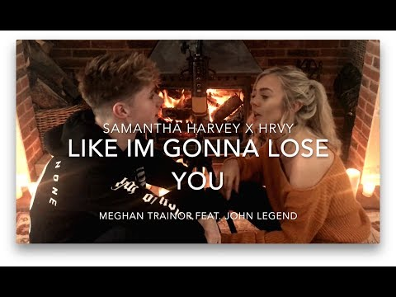](https://www.youtube.com/watch?v=Wkcd5R_0qWw)[](https://www.youtube.com/watch?v=cGVKPIQWZSY)[](https://www.youtube.com/watch?v=HAlz5TiKOCM)

**These videos are not the official music video**

Home

Next

Back



[](https://www.youtube.com/watch?v=0K_IZUGUlHM)[](https://www.youtube.com/watch?v=YKA1vnVw0f0)[](https://www.youtube.com/watch?v=1jkjB7UaXlQ)

**These videos are not the official music video**

Next

Home

Back

quotes

“Any body type is beautiful. It's all about loving what you got and rocking it.”

“I don't consider myself a feminist, but I'm down for my first opportunity to say something to the world to be so meaningful. If you asked me, 'What do you want to say?' it would be, 'Love yourself more.”  
“I wasn't strong enough to have an eating disorder. I tried to go anorexic for a good three hours. I ate ice and celery, but that's not even anorexic. And I quit. I was like, 'Ma, can you make me a sandwich? Like, immediately.”  
“When I got signed as a songwriter, I immediately thought, 'Oh, no one sees me as an artist because I don't look good enough.' So I shut down the whole idea.”

Next

Home

Back

contact us!!

ANYTHING YOU WOULD LIKE TO ASK? PLEASE FILL UP THE **FORM!**

NAME:

EMAIL ADDRESS:

PROBLEM/ISSUE/QUESTION:

SUBMIT

OUR CONTACT!

PHONE NUMBER: 012-4326654

PLEASE CALL US IF YOU HAVE TROUBLE OR QUESTIONS ABOUT THIS WORLD TOUR!

**Our Queen’s contact**



https://www.instagram.com/meghan_trainor/

Back

Home

Next